Chapter 2, Problem 33.

Obtain v and i in the circuit in Fig. 2.97.
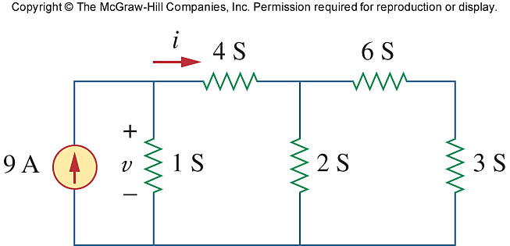

Figure 2.97
For Prob. 2.33.

